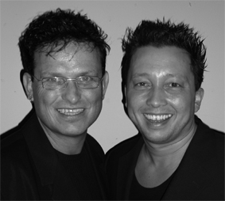
Cruisin’ Cha

Choreographers : Roy Verdonk en Wil Bos
Level : Novice (Cha Cha)
Dance : 4 wall

Counts : 32
Music : Neal McCoy – This Time I’m Takin’ My Time
Intro : 32 counts

Step, Cross Rock, Recover, Side Shuffle, Rock, Recover, Lockstep Forward

1-2-3 Step right to right side, Cross left over right, Recover
4&5 Step left to left side, Close right next to left, Step left to left side
6-7 Rock right behind left, Recover
8&1 Step right forward, Lock left behind right, Step right forward

Step, ¼ Turn, Cross Shuffle, ¾ Turn, Lockstep Forward

2-3 Step left forward, ¼ right (weight on right)
4&5 Cross left over right, Step right to right side, Cross left over right
6-7 ¼ turn left step back on right, ½ turn left step forward on left
8&1 Step right forward, Lock left behind right, Step right forward

Rock, Recover, Coaster Stap, Lockstep Forward, Step, ½ Turn Step Back, Touch

2-3 Rock left forward, Recover
4&5 Step left back, Close right next to left, Step left forward
6&7 Step right forward, Lock left behind right, Step right forward
8&1 Step left forward, ½ turn right on ball of right step back on right, Touch left in front of right

Walk, Walk, ¼ Turn Side Shuffle, Cross Rock, Recover, Side Shuffle

  - Walk forward left, Walk forward right
4&5 ¼ Turn right step left to left side, Close right next to left, Step left to left side
6-7 Cross right behind left, Recover*
8&-1 Step right to right side, Close left next to right, Step right to right side(=1st step)

- Intermediate option

2 syncopated sailor steps
6&7 Cross right behind left, Step left to left side, Step right to right side
&8& - 1 Cross left behind right, Step right to right side, Step left to left side

Start again and let the music touch your soul

